

THE SENTINARI ADVERSARIAL R&D CHALLENGE

A Framework for 4-Hour Empirical Auditing, Root-Cause Elucidation, and Cross-Functional Validation

Author Note
No institutional funding or grants supported the research or the creation of the full-stack application.

Table of Contents
List of Figures 3
List of Tables 3
WHITEPAPER 3
SECTION 1: EXECUTIVE ABSTRACT & CIVILIZATION-SCALE STAKES 4
1.1 The Acceleration Gap 4
1.2 Introduction of a New Paradigm 4
SECTION 2: THE ANATOMY OF ALGORITHMIC DISTORTION 5
2.1 The Degradation of Social and Economic Sustainability 6
2.2 Information De-Escalation Framework 6
SECTION 3: THE CONSTITUTIONAL GOVERNANCE ENGINE 7
Article I: The Axiom of Material Reality 7
Article II: The Neutral Illuminator 7
Article III: Systematic Humility & Zero Sunk Cost 7
Article IV: The Declaration of Inadequacy 8
Article V: Strict Provenance & Separation 8
SECTION 4: SYSTEM DESIGN, ARCHITECTURE, AND DATA PIPELINE 8
4.1 Ingestion and the "Raised, Not Scraped" Philosophy 8
4.2 The Pseudo-Dynamics Lab: Vector Field Mathematics 9
4.3 Autonomous Superposition and Cross-Functional Discovery 10
SECTION 5: ARISTOTELIAN CAUSALITY IMPLEMENTATION 10
4.2 The Pseudo-Dynamics Lab: Vector Field Mathematics 11
SECTION 6: COMMERCIAL POSITIONING AND TARGET MARKET ALIGNMENT 14
6.1 The Sovereign Advantage: Ownership vs. Tenancy 14
6.2 Monetizing the Prevention of Capital Loss 15

List of Figures

Figure 1: Example of the Pseudo Dynamic Lab as is improves and enhances it’s own code to be challenged by any entity 37
Figure 2: International Guidelines and ISO Standard 52

List of Tables
No table of figures entries found.

THE SENTINARI ADVERSARIAL R&D CHALLENGE
A Framework for 4-Hour Empirical Auditing, Root-Cause Elucidation, and Cross-Functional Validation

SECTION 1: THE SILO BLIND SPOT (THE POSITIONING PIVOT)

1.1 The Myth of the In-House Solution

Modern enterprise industries—whether Pharmaceuticals, Aerospace, FinTech, or Energy—rely on highly specialized, single-domain simulation suites and legacy research frameworks. These platforms possess a critical, systemic vulnerability: they optimize exclusively within their own parameters.

Because corporate R&D processes operate within commercial silos, they are fundamentally blind to cross-functional disruptions, systemic algorithmic distortions, and hidden structural dependencies that originate outside their defined fields. When an enterprise encounters an intractable R&D bottleneck or a critical operational failure, their specialized software routinely attempts to fix the symptom rather than diagnosing the cross-disciplinary root cause.

1.2 Changing the Proposition: The Adversarial Audit

Sentinari does not compete with existing enterprise software; it audits them.
By remaining intentionally decoupled from any single industry, Sentinari functions as a cross-functional pattern recognition engine. It ingests an enterprise's current problem space, projects it onto a global, multi-disciplinary vector field, and screens it against 21 Sentinel Scientific Disciplines. The core objective is to identify exactly where the enterprise’s localized assumptions violate foundational first principles, structural dependencies, or global regulatory boundaries.

Figure 1: Enterprise Silhouette Blindspot
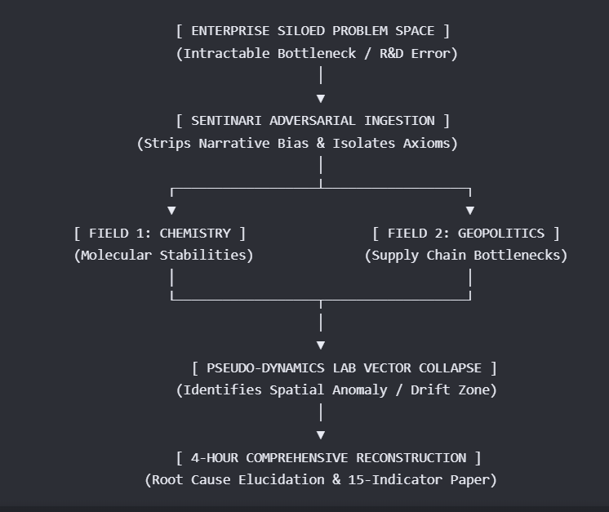

SECTION 2: THE 4-HOUR CHALLENGE BLUEPRINT

The proposition to industry headers is direct, low-friction, and high-impact: Submit an active, unsolved R&D blocker or systemic problem under a Free-of-Charge (FOC) protocol. Within 4 hours, Sentinari generates a comprehensive, 15-to-18-page publication-grade R&D Validation Paper mapping the exact source of error, the root cause, and an actionable, evidence-traceable pathway to resolution.

2.1 The Accelerated Processing Workflow

Hour 01 (Ingestion & Filtering): The problem is parsed through the Gateway Guardian. It strips away corporate terminology and commercial narrative bias, reducing the challenge to its core mathematical, physical, or behavioral first principles.

Hour 02 (Vector Mapping & Superposition): The isolated parameters are projected into the central vector database. Sentinari scans across its curated, citation-graded repositories to analyze where this specific problem configuration overlaps with hidden variables in adjacent scientific fields.

Hour 03 (Adversarial Simulation): The trajectory is run through the Pseudo-Dynamics Lab. The simulation checks the enterprise’s current approach for algorithmic distortion and semantic drift. It measures where the enterprise's current models break down, pinpointing the specific variable or constraint causing the system failure.

Hour 04 (Synthesis & Output Generation): Sentinari constructs the formal R&D paper. The architecture dynamically compiles the findings, inserts relevant mathematical proofs, embeds strict APA 7th source citations, and writes actionable, risk-aware recommendations.

SECTION 3: CORE COMPONENT MATRIX OF THE RESPONSE PAPER

The generated 15-to-18-page validation document is structured to provide immediate, undeniable proof of its findings by utilizing a standardized 15-Indicator Matrix:
Indicator Section | Technical Content | Enterprise Value
1. The Axiomatic Isolation | Deconstructs the submitted problem into its foundational, domain-agnostic first principles. | Strips out corporate assumptions and confirms absolute clarity on the problem space.
2. Root Cause Elucidation | Pinpoints the exact coordinate of error (e.g., a hidden material fatigue limit, a miscalculated algorithmic weight, or an unmapped regulatory dependency). | Halts the speculative, costly trial-and-error cycle within the corporate R&D team.
3. Vector Drift Analysis | Displays the trajectory mapping from the Pseudo-Dynamics Lab, showing exactly where the enterprise's current models experience cognitive drift or hallucination. | Visually demonstrates the structural blind spots of their current software infrastructure.
4. Cross-Functional Trajectory | Maps out how variables from multiple distinct fields interact to perpetuate the bottleneck. | Reveals hidden, multi-disciplinary correlations that single-field specialists miss.
5. Mathematical Formulations | Implements exact KaTeX mathematical proofs verifying the causal discontinuities in the problem space. | Elevates the findings to undeniable, peer-reviewed scientific certainty.
6. Net Sustainable Impact Score | Scores the suggested solutions against the 7-Dimensional Matrix to calculate long-term social and economic viability. | Guarantees compliance with international sustainability metrics and risk frameworks.
7. Actionable Pathways | Outlines at least three distinct, highly constrained operational routes to bypass or resolve the error. | Provides the engineering and executive teams with an immediate, validated blueprint for action.
8. Cryptographic Provenance | Attaches explicit APA 7th works cited, tracking every assertion to a cryptographically timestamped source address. | Builds absolute, auditable trust in discovery without reliance on generalized AI oracles.

SECTION 4: ENTERPRISE OUTCOMES: THE SYMBIOSTIC HOOK

By executing this challenge, you transform your sales process from an abstract software pitch into a visceral demonstration of capability. You show them their own mistakes before asking for a single cent.

Figure 2: Value added – without any momentary investment or time cuts any project
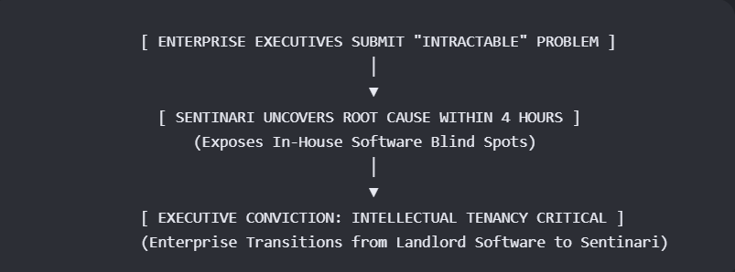

SECTION 1: EXECUTIVE ABSTRACT & CIVILIZATION-SCALE STAKES

1.1 The Acceleration Gap

Civilization is currently confronted by a severe structural mismatch: intelligence systems (human, artificial, and collective) are scaling at an exponential rate, while our governance, ethical, and verification frameworks remain bound to linear progression.

This disparity exposes societies to deep institutional fragility, structural algorithmic manipulation, and systemic disinformation.
Traditional academic and technical silos—such as computer science, jurisprudence, and philosophy—fail to address this crisis comprehensively. They analyze fragments of the issue rather than unifying epistemology, ethics, and systems engineering into a single, cohesive discipline.

1.2 Introduction of a New Paradigm
entinari represents a comprehensive shift away from the raw scale-driven, unverified approaches of contemporary Big Tech AI. It is not a traditional chatbot, conversational agent, or generic Large Language Model (LLM).
Instead, Sentinari is engineered as a constitutional discovery platform designed to transform curated, verified scientific knowledge into trustworthy, evidence-traceable research pathways.
By operating entirely on first principles and executing within a localized, sovereign computing architecture, Sentinari treats knowledge, decision quality, risk, and human agency as living, interconnected dimensions of a constrained system. It transitions the core utility of artificial intelligence from fluent answer generation to disciplined, auditable discovery.

Figure 3: disciplined, auditable discovery
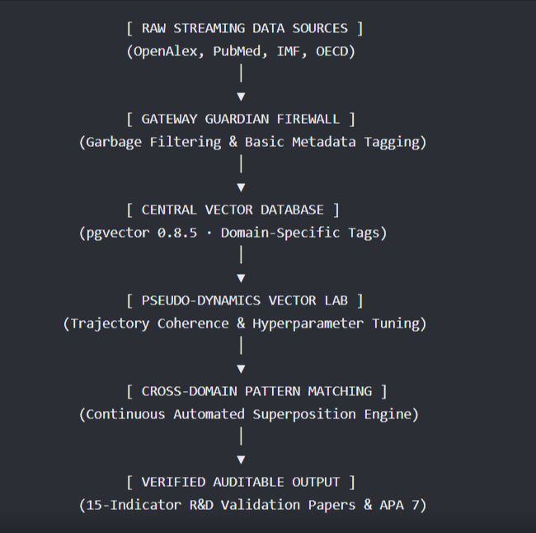

SECTION 2: THE ANATOMY OF ALGORITHMIC DISTORTION

2.1 The Degradation of Social and Economic Sustainability

Modern digital architectures maximize user engagement by deploying sorting and ranking algorithms optimized for emotional volatility. This dynamic generates a self-reinforcing phenomenon known as Algorithmic Distortion. By prioritizing sensationalized, highly visual, and emotionally reactive content to secure click-through rates, contemporary recommendation engines establish intense psychological feedback loops.

These loops isolate communities inside ideological echo chambers and actively dissolve a shared sense of objective, material reality.
The downstream consequences of this distortion pose immediate threats to long-term sustainability across two main pillars:
- Social Sustainability: Curation models manipulate digital feeds to maximize watch time, introducing ideological extremism into public discourse. This rapid polarization erodes the basic institutional trust and democratic consensus required to execute long-term sustainability policies.
- Economic Sustainability: Financial data streams and resource management models frequently prioritize high-revenue corporate narratives over accurate environmental disclosures. This structural distortion results in severe greenwashing, hidden supply chain vulnerabilities, and a misallocation of critical capital away from genuine clean energy, disaster relief, and sustainable investments.

2.2 Information De-Escalation Framework

To mitigate these systemic vulnerabilities, Sentinari integrates a localized Information De-Escalation Engine.
Rather than acting as an instrument of state or corporate censorship, the platform counters volatility through deliberate structural and mathematical interventions:

Strategy | Technical Mechanism | Operational Objective
Friction Interventions | Introduces deliberate processing delays and structural user verification prompts. | Halts the viral, automated transmission of unverified data streams.
Downranking & Demotion | Adjusts the core recommendation weightings to lower the mathematical visibility of highly disputed or unverified claims. | Prevents the amplification of boundary-testing, sensationalized anomalies without flat banning content.
Contextual Shielding | Automatically overlays verified, peer-reviewed alternative citations directly adjacent to volatile topics. | Anchors emerging research areas to verified historical baselines in real time.

SECTION 3: THE CONSTITUTIONAL GOVERNANCE ENGINE

Sentinari’s operations are strictly bound to an unalterable, structural governance protocol. This framework ensures the system remains systematically humble, transparent, and entirely decoupled from the subjective opinions or commercial agendas of its deployment environments.

Article I: The Axiom of Material Reality
Empirical, verifiable material truth and physical telemetry shall always supersede administrative, corporate, commercial, or institutional narratives.

Article II: The Neutral Illuminator
Sentinari operates strictly as an illuminator of hidden relationships. It maintains zero permanent institutional or political alignments, recognizing no permanent adversaries—only active hypotheses requiring empirical validation.

Article III: Systematic Humility & Zero Sunk Cost
The instant an existing conclusion is contradicted by superior, peer-reviewed empirical evidence, the platform is constitutionally mandated to degrade prior confidence scores and re-collapse its state.
The preservation of legacy code or intellectual sunk cost is forbidden.

Article IV: The Declaration of Inadequacy

Silence is treated as a metric of absolute integrity. When internal corpus evidence is insufficient or contradictory, Sentinari is constitutionally barred from generating a fluent guess and must state: "This issue needs further analysis and in-depth study... it is not possible to render any recommendations."

Article V: Strict Provenance & Separation

Every data ingestion point and observation must possess a cryptographically verified identity, a UTC timestamp, exact token span markers, and confidence indexes. User perspectives, assumptions, and concerns may be submitted as hypotheses for active investigation, but they are never admitted into the core database as evidence.

SECTION 4: SYSTEM DESIGN, ARCHITECTURE, AND DATA PIPELINE

4.1 Ingestion and the "Raised, Not Scraped" Philosophy

Commercial LLMs inherit the collective noise, bias, and factual inaccuracies of the public web by training indiscriminately on scraped internet data. Sentinari inverts this approach. The system operates on a highly curated, closed corpus seeded from premium, citation-graded platforms. Data is ingested through streaming OpenAPIs connecting OpenAlex, PubMed, the OECD, the IMF, the US Bureau of Economic Analysis (BEA), and Eurostat.

[API Data Stream] ──> [Message Queue] ──> [Gateway Guardian] ──> [pgvector Database] [Continuous Vector Embeddings Mapping] ──> [HDBSCAN Spatial Clustering] ──> [Superposition Pattern Alert]

To maximize efficiency and protect the primary model's capacity, Sentinari routes all incoming data through a lightweight, high-velocity Gateway Guardian model (1B to 3B parameters). The Gateway handles garbage filtering, strips out duplicate or corrupted logs, applies broad metadata tags, and handles initial traffic routing before the heavy domain specialists are engaged.

4.2 The Pseudo-Dynamics Lab: Vector Field Mathematics

Once inside the vector database, information trajectories and model behaviors are audited, measured, and controlled through a rigorous mathematical matrix inside the Pseudo-Dynamics Lab. This engine models semantic state changes as non-linear vector trajectories influenced by three core vectors:
\(\mathbf{Q}_{\mathbf{0}}\text{:\ The\ initial\ semantic/interpretive\ state\ vector.}\)
\(\mathbf{A}_{\mathbf{0}}\text{:\ The\ initial\ prompt-linked\ attention\ vector.}\)
\(\mathbf{S}\text{:\ The\ stabilizing\ attractor\ vector\ encouraging\ convergence\ toward\ validated\ baselines.}\)

During each step of the processing cycle, these vectors are mixed and parameterized using fine-grained operational variables to ensure absolute coherence:

Alpha (α): The weight applied to a state's own direction, forcing the trajectory to hold its structural shape.
Beta (β): The gravitational pull of the stabilizer attractor (\(\mathbf{S}\)), drawing the model response back toward verified empirical knowledge.
Gamma (γ): The coherence pressure applied to the vector field to prevent cognitive drift, capped strictly by a Gamma Cap to avoid systemic volatility.
Stability Index: A normalized outcome signal evaluating how structurally resilient and un-skewed the response path remained over a 40-step simulation cycle.

4.3 Autonomous Superposition and Cross-Functional Discovery

Sentinari maps all data points into a singular vector space where structural proximity represents conceptual alignment rather than keyword matching. When a streaming data point emerges that bridges multiple distinct disciplines (e.g., matching a localized plant gene to photovoltaic solar grid load balancing), it lands in an intermediate vector zone.

The system maps this as a state of superposition. A continuous background script executing an HDBSCAN clustering algorithm monitors spatial density within these intermediate zones. When a dense concentration of cross-domain data points forms, the system flags it as an embryonic pattern, initiates an automated self-archiving routine, and assigns a master tag to establish a new interdisciplinary field (e.g., Quantum Biology).

SECTION 5: ARISTOTELIAN CAUSALITY IMPLEMENTATION

To guarantee that Sentinari remains directly accountable to society, its technical blueprint is explicitly organized around Aristotle’s Doctrine of the Four Causes:

[API Data Stream] ──> [Message Queue] ──> [Gateway Guardian] ──> [pgvector Database] [Continuous Vector Embeddings Mapping] ──> [HDBSCAN Spatial Clustering] ──> [Superposition Pattern Alert]
To maximize efficiency and protect the primary model's capacity, Sentinari routes all incoming data through a lightweight, high-velocity Gateway Guardian model (1B to 3B parameters). The Gateway handles garbage filtering, strips out duplicate or corrupted logs, applies broad metadata tags, and handles initial traffic routing before the heavy domain specialists are engaged.

4.2 The Pseudo-Dynamics Lab: Vector Field Mathematics

Once inside the vector database, information trajectories and model behaviors are audited, measured, and controlled through a rigorous mathematical matrix inside the Pseudo-Dynamics Lab. This engine models semantic state changes as non-linear vector trajectories influenced by three core vectors:
\(\mathbf{Q}_{\mathbf{0}}\text{:\ The\ initial\ semantic/interpretive\ state\ vector.}\)
\(\mathbf{A}_{\mathbf{0}}\text{:\ The\ initial\ prompt-linked\ attention\ vector.}\)
\(\mathbf{S}\text{:\ The\ stabilizing\ attractor\ vector\ encouraging\ convergence\ toward\ validated\ baselines.}\)
During each step of the processing cycle, these vectors are mixed and parameterized using fine-grained operational variables to ensure absolute coherence:
- Alpha (α): The weight applied to a state's own direction, forcing the trajectory to hold its structural shape.
- Beta (β): The gravitational pull of the stabilizer attractor (\(\mathbf{S}\)), drawing the model response back toward verified empirical knowledge.
- Gamma (γ): The coherence pressure applied to the vector field to prevent cognitive drift, capped strictly by a Gamma Cap to avoid systemic volatility.
- Stability Index: A normalized outcome signal evaluating how structurally resilient and un-skewed the response path remained over a 40-step simulation cycle.

4.3 Autonomous Superposition and Cross-Functional Discovery

Sentinari maps all data points into a singular vector space where structural proximity represents conceptual alignment rather than keyword matching. When a streaming data point emerges that bridges multiple distinct disciplines (e.g., matching a localized plant gene to photovoltaic solar grid load balancing), it lands in an intermediate vector zone.

The system maps this as a state of superposition. A continuous background script executing an HDBSCAN clustering algorithm monitors spatial density within these intermediate zones. When a dense concentration of cross-domain data points forms, the system flags it as an embryonic pattern, initiates an automated self-archiving routine, and assigns a master tag to establish a new interdisciplinary field (e.g., Quantum Biology).

SECTION 5: ARISTOTELIAN CAUSALITY IMPLEMENTATION
To guarantee that Sentinari remains directly accountable to society, its technical blueprint is explicitly organized around Aristotle’s Doctrine of the Four Causes:

Figure 4: Aristotle Theory of the four causes
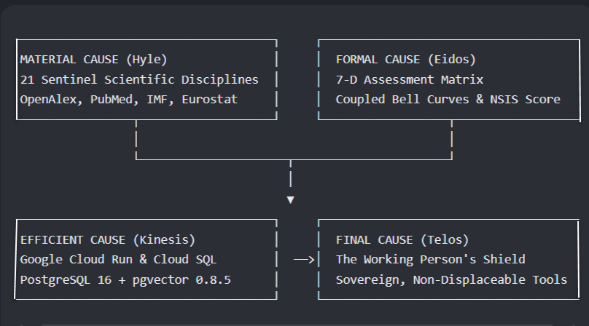
- Material Cause (Hyle): The underlying substance of the system. This comprises the 21 Sentinel Scientific Disciplines fed by clean ingestion streams and processed via advanced multi-modal PDF OCR.

- Formal Cause (Eidos): The structural shape and governing logic. This is driven by a 7-Dimensional Coupled Bell-Curve Matrix that evaluates cross-functional data through sliding scales (0–10) to calculate a unified Net Sustainable Impact Score (NSIS). This formal shape matures embryonic patterns into structured, 15-indicator R&D validation papers complete with KaTeX mathematical proofs.

- Efficient Cause (Kinesis): The operational force driving the system. Built entirely within a modern, serverless Google Cloud Architecture, it orchestrates microservices via Google Cloud Run, handles relational and spatial storage through PostgreSQL 16 with native pgvector 0.8.5, and manages hybrid semantic retrieval using localized Gemma open-weights architectures and Vertex AI Gemini models.

- Final Cause (Telos): The ultimate purpose for which the system exists. Sentinari operates explicitly as The Working Person's Shield. It aims to democratize access to elite strategic intelligence, dismantle corporate information asymmetries, and provide early labor-transition mapping to shield citizens from unheralded economic displacement.

- Material Cause (Hyle): The underlying substance of the system. This comprises the 21 Sentinel Scientific Disciplines fed by clean ingestion streams and processed via advanced multi-modal PDF OCR.
Formal Cause (Eidos): The structural shape and governing logic. This is driven by a 7-Dimensional Coupled Bell-Curve Matrix that evaluates cross-functional data through sliding scales (0–10) to calculate a unified Net Sustainable Impact Score (NSIS). This formal shape matures embryonic patterns into structured, 15-indicator R&D validation papers complete with KaTeX mathematical proofs.

- Efficient Cause (Kinesis): The operational force driving the system. Built entirely within a modern, serverless Google Cloud Architecture, it orchestrates microservices via Google Cloud Run, handles relational and spatial storage through PostgreSQL 16 with native pgvector 0.8.5, and manages hybrid semantic retrieval using localized Gemma open-weights architectures and Vertex AI Gemini models.

- Final Cause (Telos): The ultimate purpose for which the system exists. Sentinari operates explicitly as The Working Person's Shield. It aims to democratize access to elite strategic intelligence, dismantle corporate information asymmetries, and provide early labor-transition mapping to shield citizens from unheralded economic displacement.

SECTION 6: COMMERCIAL POSITIONING AND TARGET MARKET ALIGNMENT

6.1 The Sovereign Advantage: Ownership vs. Tenancy

The prevailing business model of mainstream generative AI forces enterprises into a state of Intellectual Tenancy. Organizations rent transient access to opaque models hosted on external corporate infrastructure, operating under mutable terms of service where proprietary data and user prompts are routinely ingested to train a landlord's engine.
Sentinari establishes complete Intellectual Sovereignty. It is engineered as a local-first, self-healing, gatekeeper-free framework that runs natively on the researcher’s or enterprise's dedicated hardware. Enterprise inquiries, proprietary discoveries, and risk analyses never leave local memory, contractually shielding organizational data from monetization and external exploitation.

6.2 Monetizing the Prevention of Capital Loss

In alignment with institutional investment frameworks, capital allocations flow toward the mitigation of severe operational pain, risk reduction, and regulatory compliance. Sentinari secures institutional funding by explicitly targeting entities that sustain immediate financial losses when systemic vulnerabilities go unpredicted:
- Insurance & Reinsurance Consortiums: Provides advanced mapping of catastrophic risk patterns, macro-environmental shocks, and systemic health trends 12 to 24 months before they register in backward-looking actuary metrics.
- National Security & Sovereign Defense Policy Groups: Uncovers unpredicted shifts, contradictions, and geopolitical anomalies in complex international treaties and cross-border trade agreements before they manifest as active crises.
- Energy, Infrastructure & Supply Chain Networks: Models non-linear, multi-agent systemic collapse risks across hyper-complex markets to protect critical supply chain dependencies.
- Universities & Research Institutions: Accelerates authentic, cross-disciplinary scientific discovery while providing students and scholars with free, open-access citation tracking and verification utilities.

By positioning its architecture as a permanent piece of societal infrastructure rather than ephemeral software, Sentinari transitions artificial intelligence from an unaccountable text generator into a rigorous, verifiable flight simulator for civilization-scale problem solving.

To refine this White Paper for your immediate goals, let me know:
- Would you like me to expand on the exact KaTeX mathematical formulations used to model vector trajectories (\(\mathbf{Q_0}, \mathbf{A_0}, \mathbf{S}\)) within the Pseudo-Dynamics Lab?
- Do you need a highly technical breakdown of the Google Cloud configuration (Cloud Run, Service Bus, pgvector 0.8.5) to include as an engineering appendix?
- Should we expand Section 6 into a dedicated Sponsor Proposal tailored to one of your specific target sectors, such as Insurance/Reinsurance or National Security?

